Verify they are dialing this number “30-70090”:

1. On the VCCD application go to “Tools drop menu”

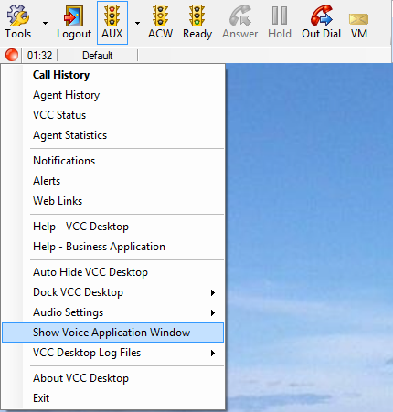

1. Select “Show Voice Application Window”

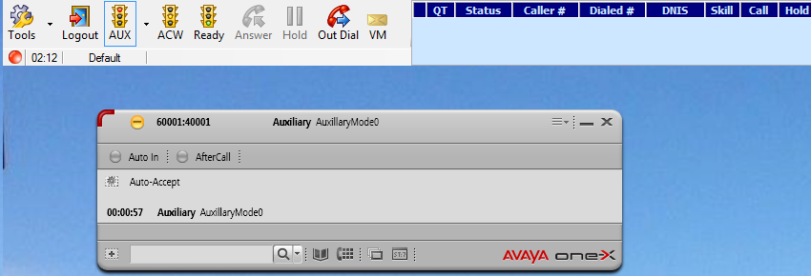

1. At the top right hand corner find the 3 dashes and select the drop down menu
2. Next select the “System Settings”

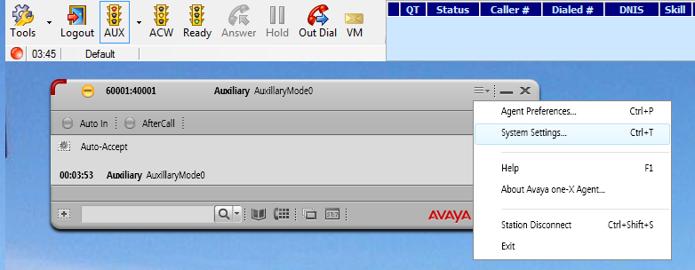

1. On the left window of the “System Settings” find and select “Voice Mail Integration”

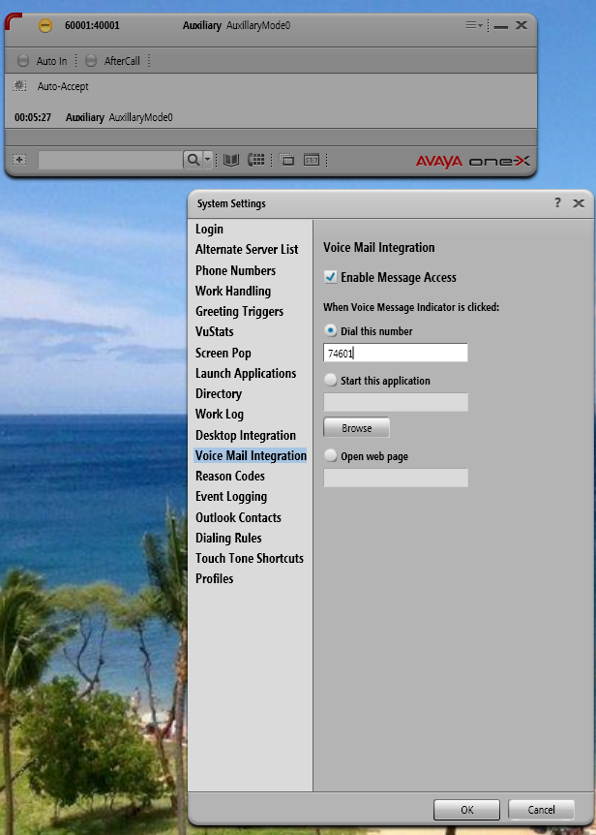

1. On the Right hand side fine “Dial this number” it should be 30-70090, If it is any other number change it to 30-70090 and click okay